**Bury the dead**

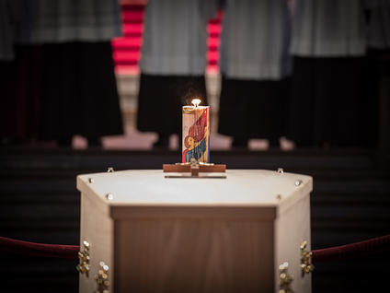

**Shelter the homeless**

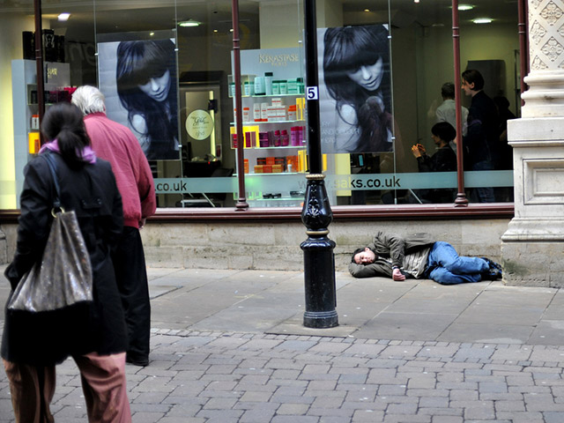

**Feed the hungry**

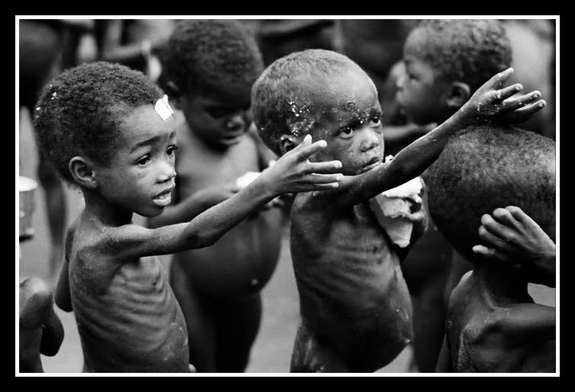

**(Credit – The catholic catalogue)**

**Give drink to the thirsty**

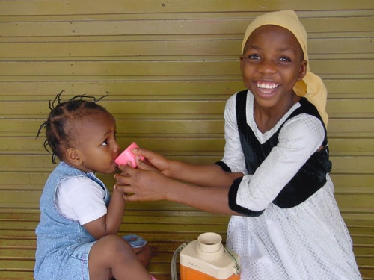

**Clothe the naked**



**(Credit – The catholic Hearld)**

**Visit the imprisoned**

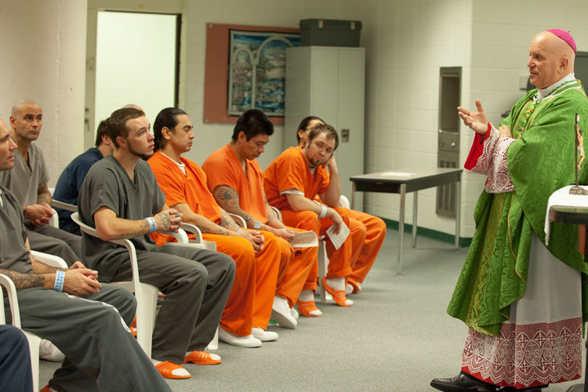

**Visit the Sick**

